

**Department of Electrical and Computer Engineering**

| Course Number | CPS510 |
| --- | --- |
| Course Title | Database Systems I |
| Semester/Year | F2022 |
| Instructor | Dr. S. B. Tajali |
| Lab Section | 7 |

| Assignment No. | 5 |
| --- | --- |
| Assignment Title | Assignment 5: Demonstration of Advanced Queries by Unix shell Implementation |

| Submission Date: | October 24, 2022 |
| --- | --- |
| Due Date: | October 24, 2022 |

| Student Name | Ethan Moo-Young | Ernestine Ho | Abel Abraham Thomas |
| --- | --- | --- | --- |
| Student ID | 501016708 | 501022253 | 501029194 |
| Signature |  |  |  |

Contents of [Book] Table

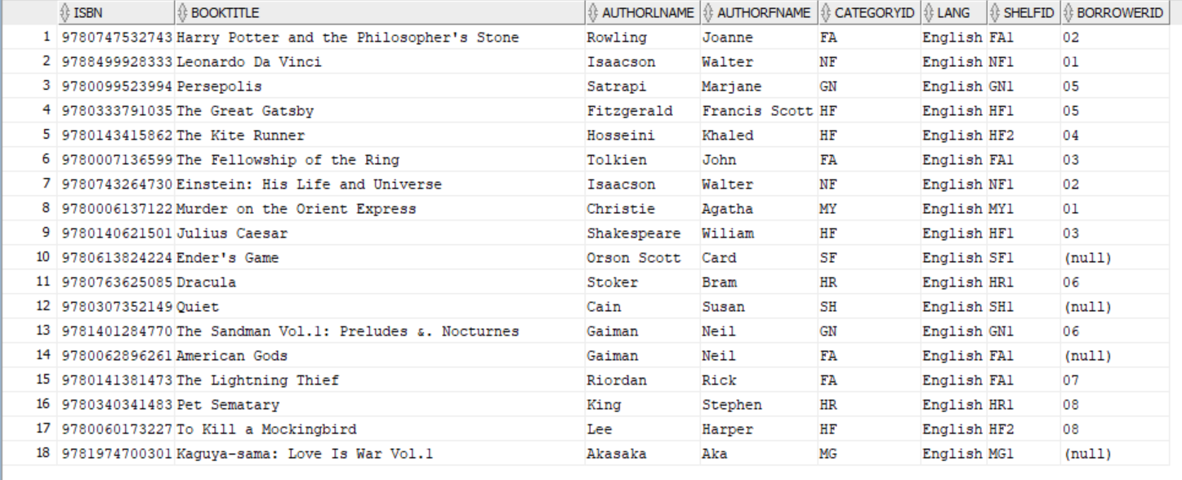

Contents of [Category] Table

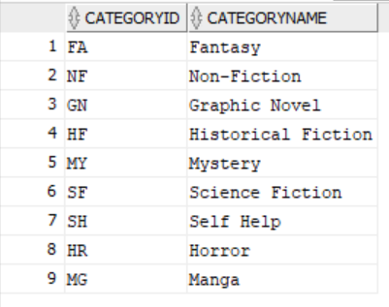

Contents of [Client] Table

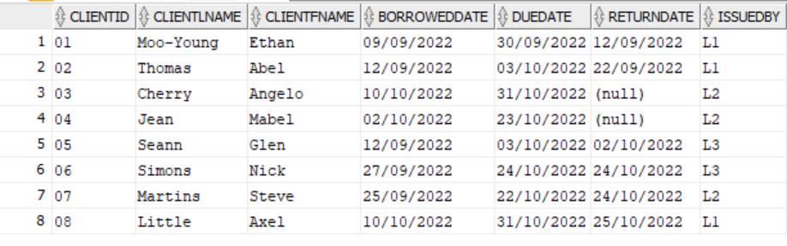

Contents of [Shelf] Table

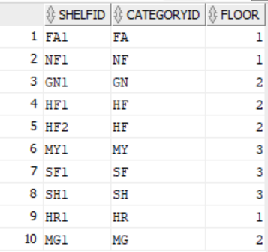

Contents of [Staff] Table

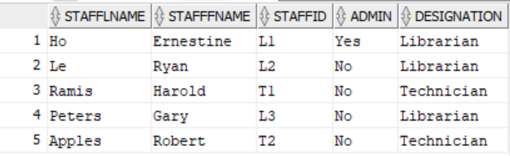

Unix Scripts:



create_tables.sh

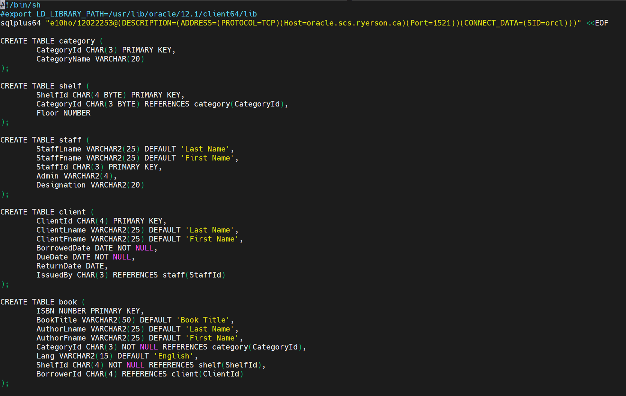

drop_tables.sh

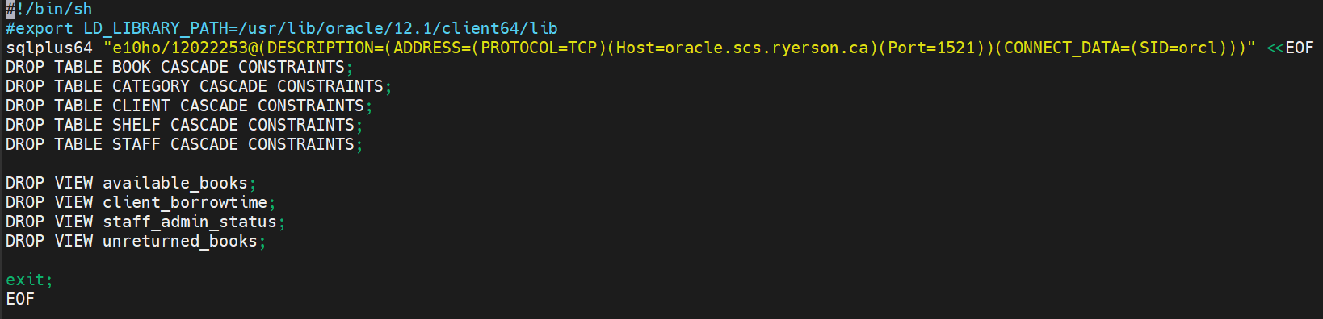

populate_tables.sh

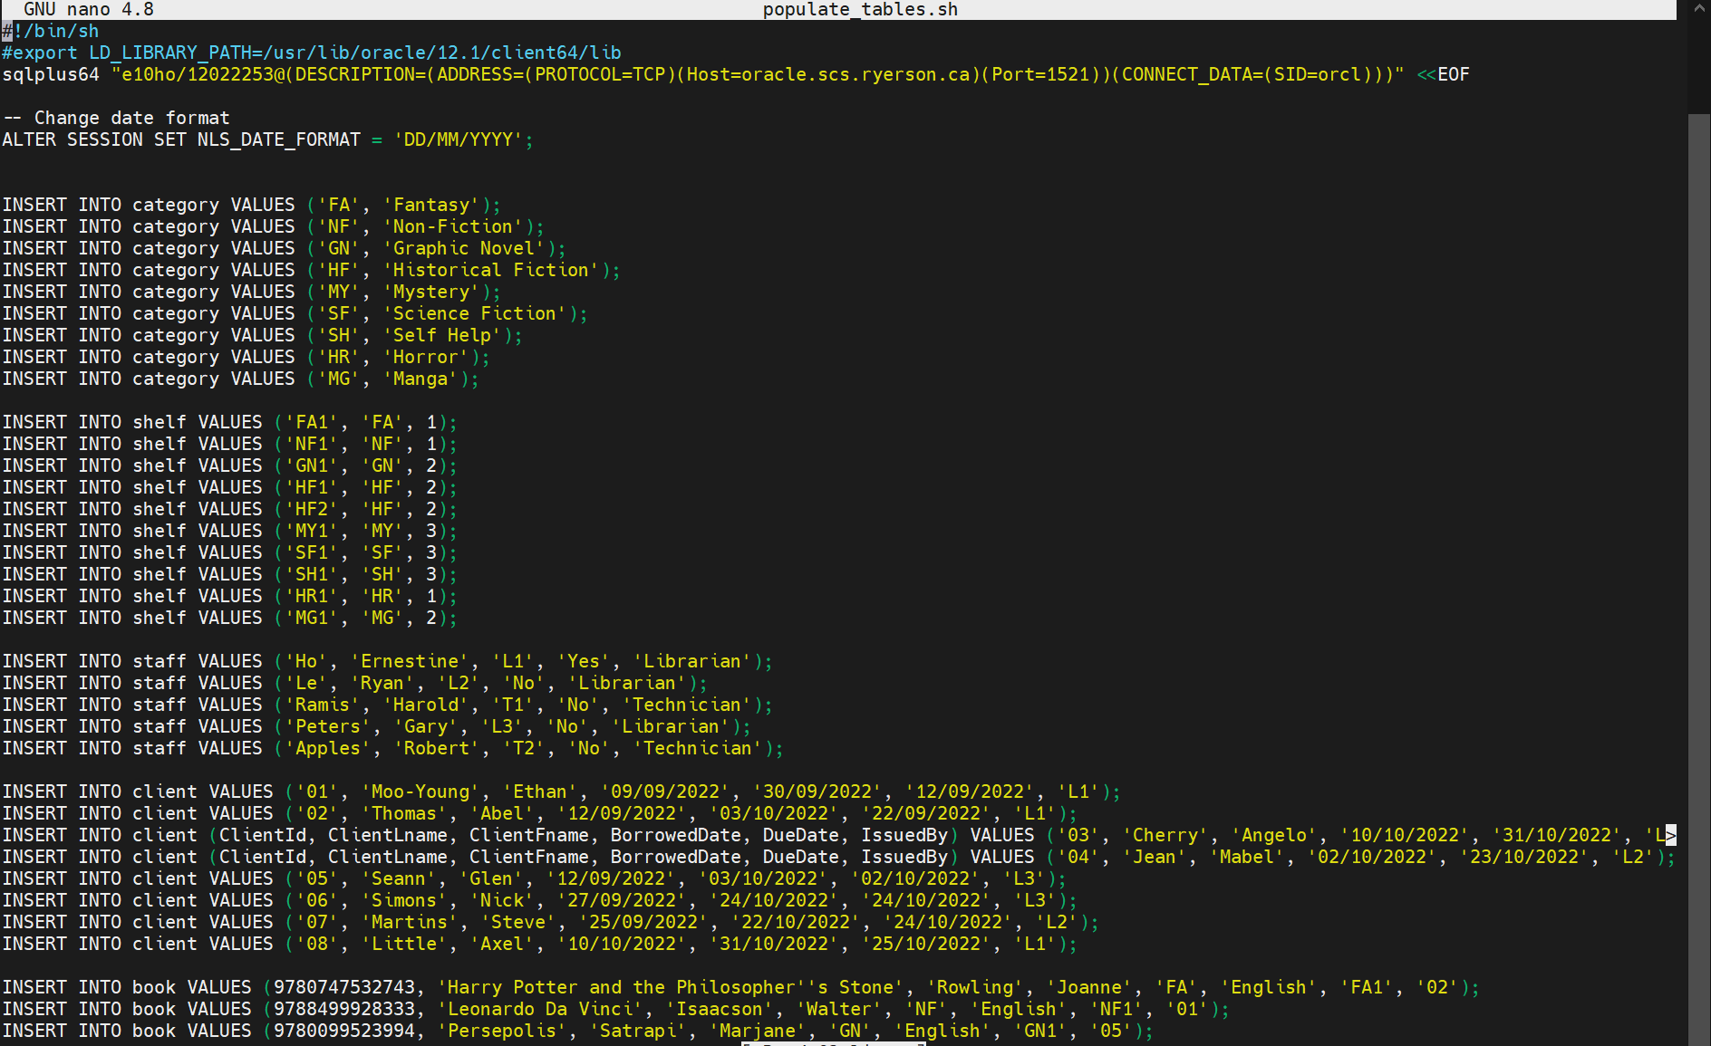

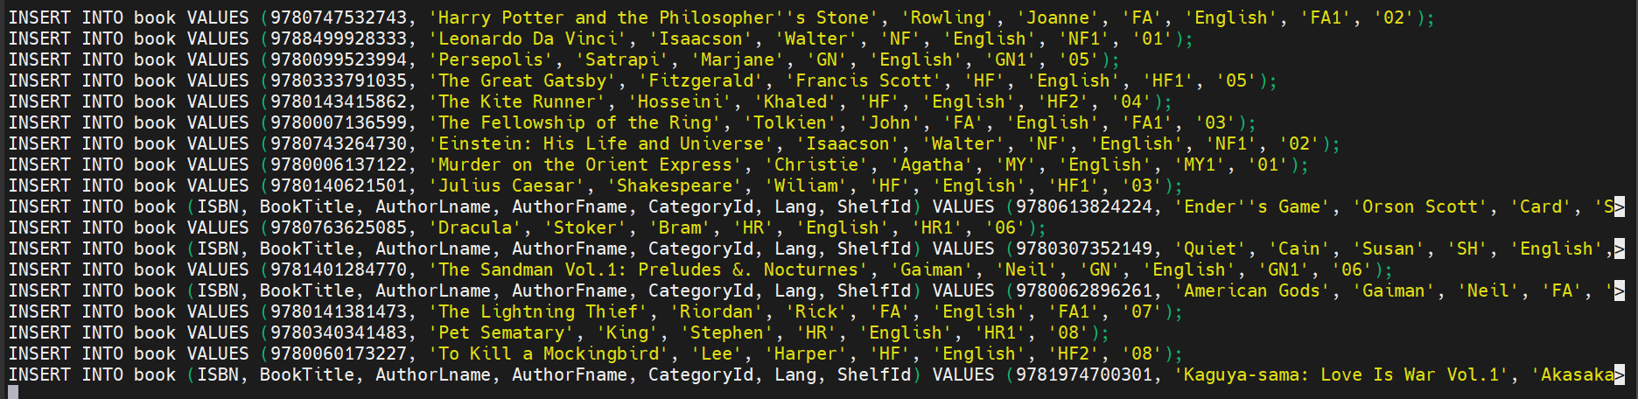

queries.sh

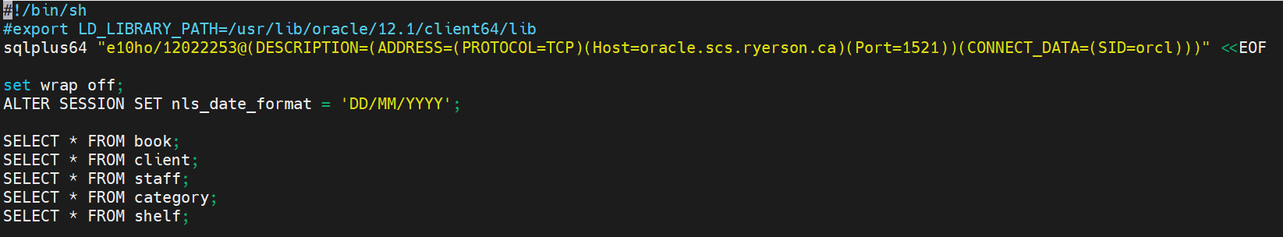

view_table.sh

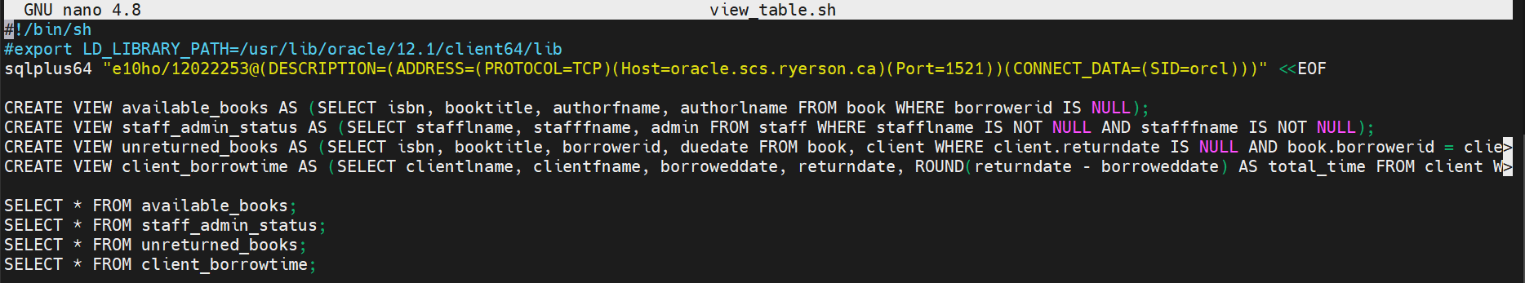

Advanced Queries:

counting all the books (tested)

SELECT DISTINCT isbn, booktitle, COUNT (*) AS totalbooks

FROM book

WHERE isbn IS NOT NULL

GROUP BY isbn, booktitle;

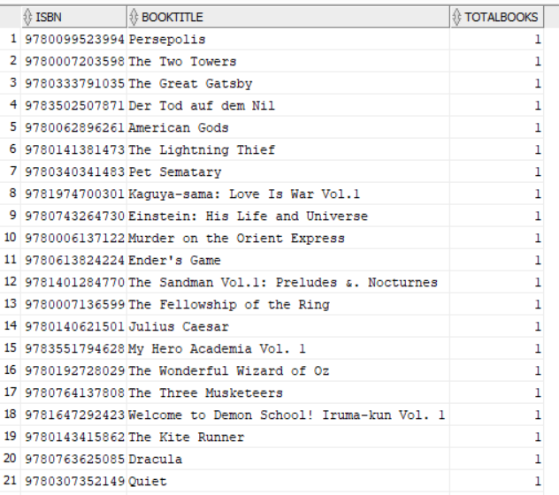

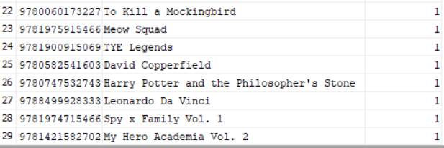

Old result :

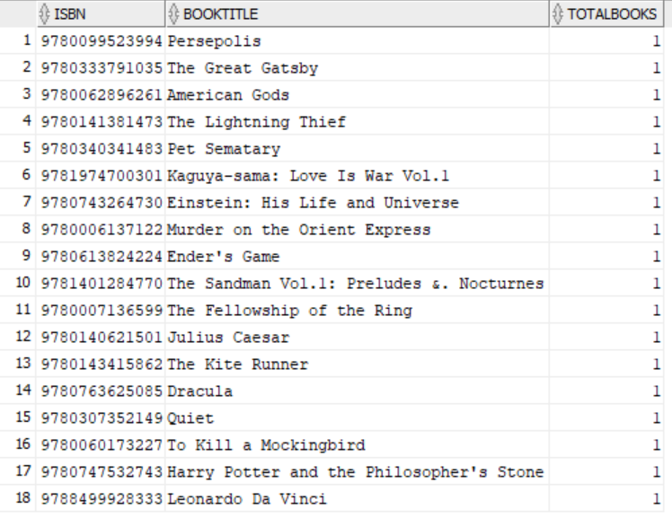

Number of books issued by each librarian

SELECT stafflname, stafffname, staffid, COUNT (issuedby) AS booksissued

FROM client, staff

WHERE client.issuedby = staff.staffid

GROUP BY stafflname, stafffname, staffid;

New: tested

SELECT stafflname, stafffname, staffid, COUNT (b.issuedby) AS booksissued FROM client c, staff, borrowedbooks b WHERE c.clientid = b.borrowerid AND b.issuedby = staff.staffid GROUP BY stafflname, stafffname, staffid;

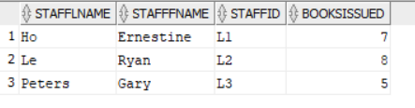

Old result :

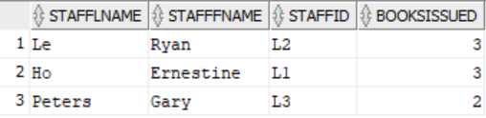

Books borrowed from clients who have not returned their books

SELECT booktitle, isbn, clientlname, clientfname, duedate

FROM book b, client c

WHERE returndate IS NULL AND c.clientid = b.borrowerid;

New: tested

SELECT b.booktitle, b.isbn, clientlname, clientfname, duedate FROM book b, client c, borrowedbooks bb WHERE returndate IS NULL AND b.isbn = bb.isbn AND c.clientid = bb.borrowerid;

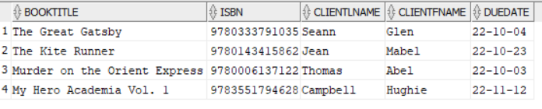

Old result :

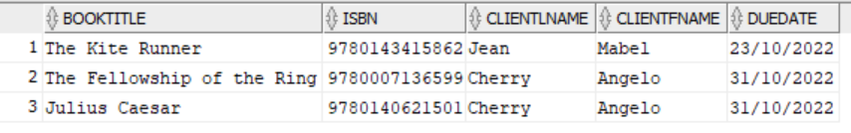

Floor question ignore

Books from shelves located on the first floor

SELECT isbn, booktitle, b.shelfid, floor

FROM shelf s, book b

WHERE floor = 1 AND s.shelfid = b.shelfid;

new:tested

SELECT isbn, booktitle, shelfid, floor FROM shelf s, book b WHERE floor = 1 AND s.categoryid = b.categoryid;

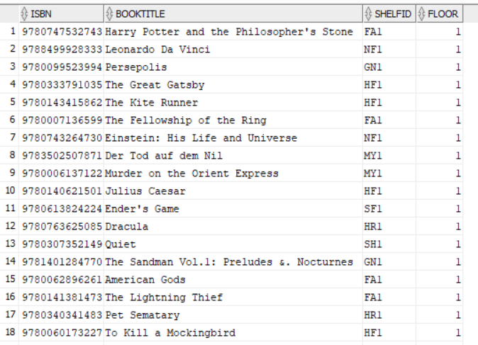

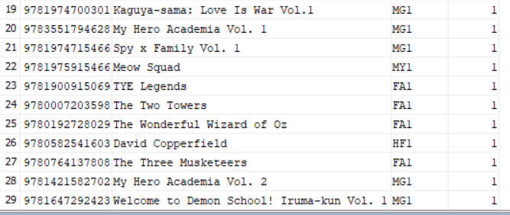

Old result :

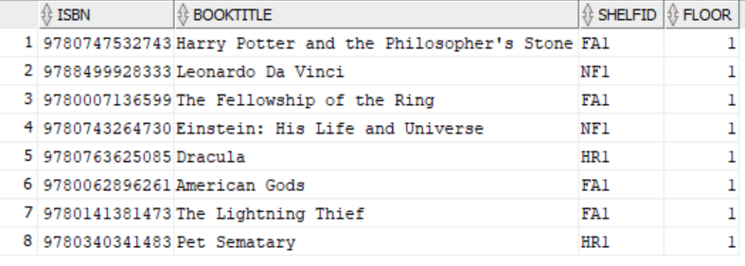

Ignored cuz floor question

Books located on the third floor

SELECT b.isbn, b.booktitle, b.categoryid

FROM book b WHERE EXISTS (SELECT c.categoryid, floor FROM category c, shelf s WHERE floor = 3 AND c.categoryid = s.categoryid AND b.categoryid = c.categoryid);

Old result :

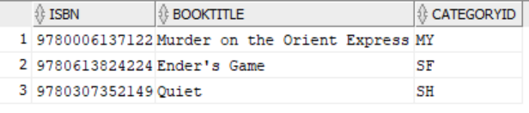

How long it takes for clients to return books

SELECT clientid, clientlname, clientfname, AVG(returndate - borroweddate)

FROM client GROUP BY clientid, clientlname, clientfname

HAVING AVG(returndate - borroweddate) > (SELECT AVG(returndate - borroweddate) FROM client);

New:tested

SELECT clientid, clientlname, clientfname, AVG(returndate - borrowerdate) FROM client c, borrowedbooks b WHERE c.clientid = b.borrowerid GROUP BY clientid, clientlname, clientfname HAVING AVG(returndate - borrowerdate) > (SELECT AVG(returndate - borrowerdate) FROM client, borrowedbooks );

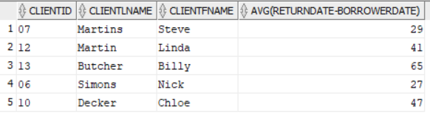

Old result :

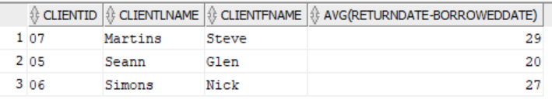

Clients who returned their books on time

SELECT * FROM client c WHERE NOT EXISTS (SELECT * FROM client WHERE returndate IS NOT NULL) UNION (SELECT * FROM client WHERE returndate < duedate);

New:

SELECT clientid, clientlname, clientfname, borrowerdate, duedate, returndate, issuedby FROM client c, borrowedbooks b

WHERE b.borrowerid = c.clientid AND NOT EXISTS (SELECT clientid, clientlname, clientfname, borrowerdate, duedate, returndate, issuedby FROM borrowedbooks, client

WHERE returndate IS NOT NULL AND b.borrowerid = c.clientid) UNION

(SELECT clientid, clientlname, clientfname, borrowerdate, duedate, returndate, issuedby FROM borrowedbooks,client WHERE returndate < duedate );

Old result :

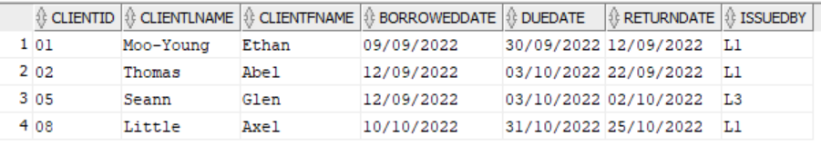

Clients who have not returned their books and returned their books late

SELECT * FROM client c WHERE EXISTS (SELECT * FROM client WHERE returndate IS NOT NULL) MINUS (SELECT * FROM client WHERE returndate < duedate);

New tested:

SELECT clientid, clientlname, clientfname, borrowerdate, duedate, returndate, issuedby

FROM client c, borrowedbooks b

WHERE b.borrowerid = c.clientid AND EXISTS (SELECT clientid, clientlname, clientfname, borrowerdate, duedate, returndate, issuedby FROM client , borrowedbooks WHERE returndate IS NOT NULL) MINUS (SELECT clientid, clientlname, clientfname, borrowerdate, duedate, returndate, issuedby

FROM client, borrowedbooks WHERE returndate < duedate);

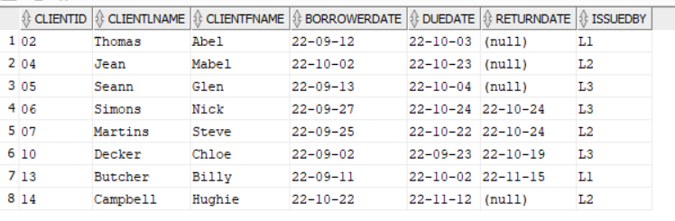

Old result :

